SDEV300

Mark Kardash

Pylint Testing:

I decided to talk about the Pylint grading of my program first, as I did that before testing it with actual inputs, to make sure it was formatted correctly. My initial score was 8.63/10.00, and that was mostly due to some lines of code being too long. Text

This continued for several attempts, as I did not know how to fix them.

When I finally realized what was being asked from me, I corrected some of the lines, causing my score t climb to 8.85.

After some more line rearrangements, I got a 9.25

And then a 9.62

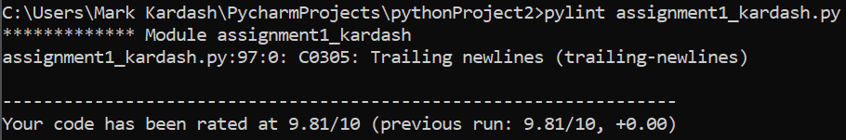

And a 9.81

It took me a while to understand what a trailing newline was, but, after some research, I finally discovered I could use the .rstrip command to get rid of it.

This gave me a score of 10.00/10, which I verified by re-grading twice.

Test Cases:

|  |  |  |  |  |
| --- | --- | --- | --- | --- |
| Test Case: | Input (In order): | Expected Output: | Actual Output | Pass? |
| 1 | yes, Anthony, yes, Smith, yes, 18, yes, yes, yes, MD, yes, 21224 | Thanks for registering to vote. Here is the information we received:  Name (first last): Anthony Smith  Age: 18  U.S. Citizen: yes  State: MD  Zipcode: 21224  Thanks for trying the Voter Registration Application. Your voter  registration card  should be shipped within 3 weeks. | Thanks for registering to vote. Here is the information we received:  Name (first last): Anthony Smith  Age: 18  U.S. Citizen: yes  State: MD  Zipcode: 21224  Thanks for trying the Voter Registration Application. Your voter  registration card  should be shipped within 3 weeks. | Yes |
| 2 | yes, Adam, yes, Lynn, no, no | Thank you for using the Voter Registration Program!  Have a great day! | “Do you want to continue with voter registration?” prompt repeats, and, upon second answer “no”, expected message is displayed, but followed by an error message. | No (Partially) |
| 3 | yes, Sofia, yes, Alvarez, yes, 15 | You must be a legal adult (Over 18) to vote.  Then the program gives a second chance, asking “How old are you?” again. | You must be a legal adult (Over 18) to vote.  Then the program gives a second chance, asking “How old are you?” again. | Yes |

Test Case 1 Screenshots:

Test Case 2 Screenshot:

*I apologize, I forgot I had to run it from cmd.